Get PUK Setup
V1.1

1. Pre-requisites: 3
2. Download Source code from GIT 3
2.1 PUK application 3
2.2 PUK Fake service 4
3. Set environment variables 5
4. Build Application 7
4.1 PUK Application 7
4.2 Fake services 7
5. Deploy Application 7
5.1 Without fake services i.e. connect to AG 7
5.2 With fake services i.e. connect to Fakes instead to AG 8
6. Running the Application 9

Pre-requisites:

- Access to Online_PUK git repo. If not then request access from DevO2.
- Download below software on your machine.
  - Gradle 2.4
  - apache-tomcat-8.5.8
  - ConEmu (if on windows machine) (Command prompt Terminals)
  - Java 8 (1.8.111)

Download Source code from GIT

2.1 PUK application

Clone following git repo to your local machine at a location say it as PUK_BASE

git clone https://github.com/O2IP/Online_PUK.git

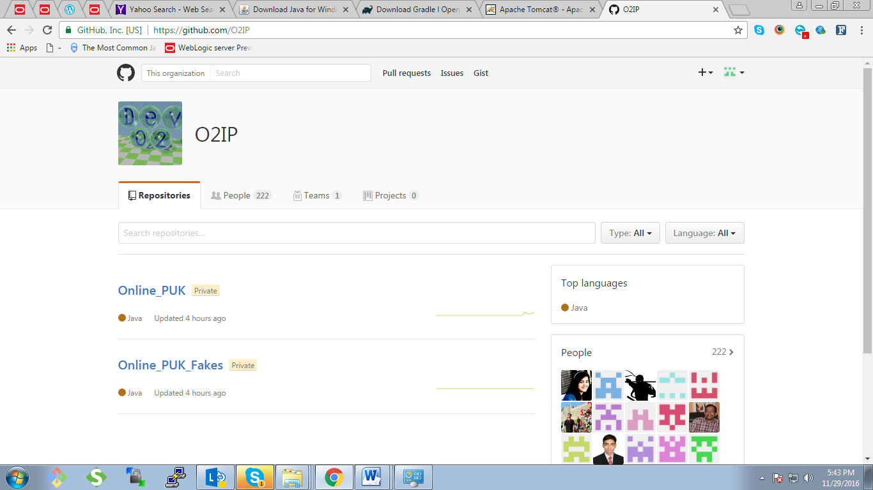

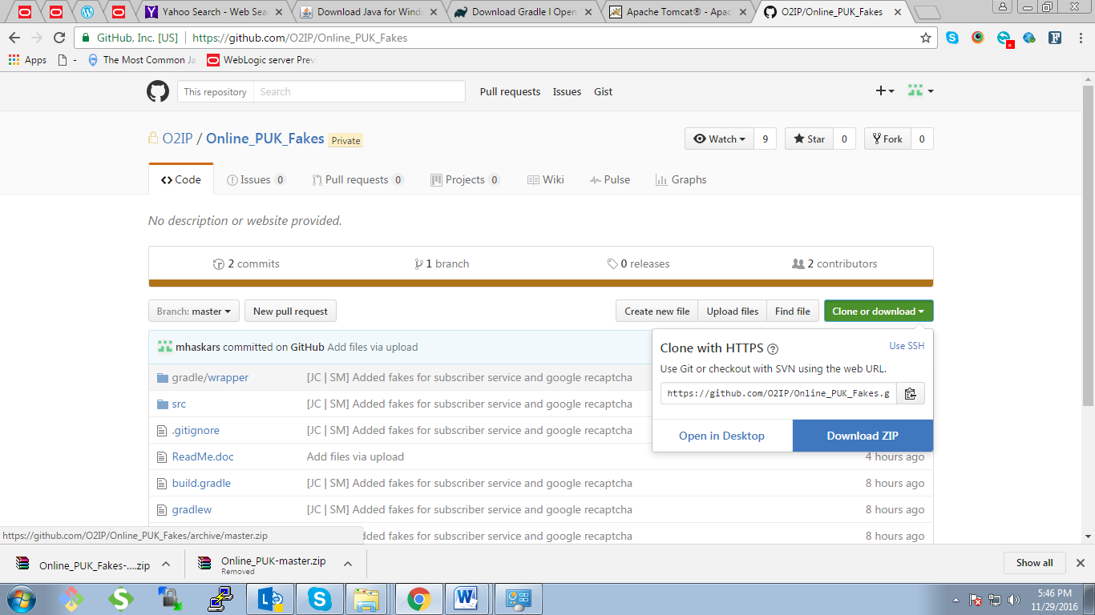

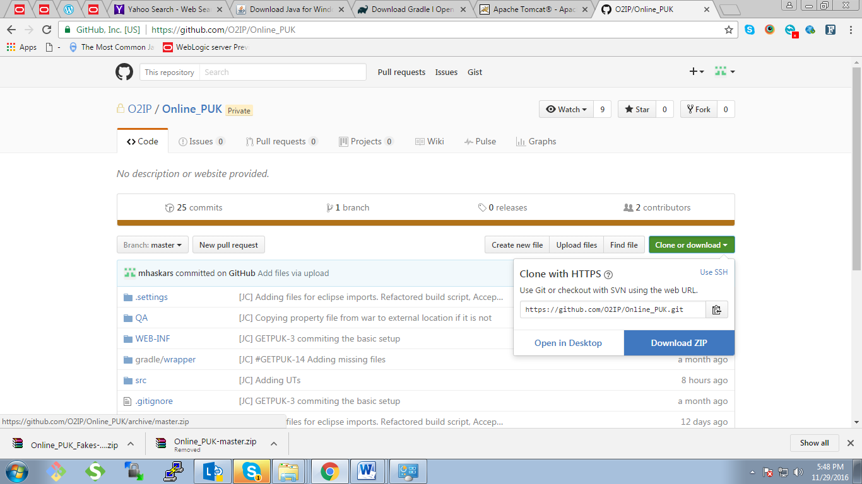

2.2 PUK Fake service

Clone following git repo to your local machine at a location say as PUK_FAKE_BASE
git clone https://github.com/O2IP/Online_PUK_Fakes.git

Set environment variables
  - Set CATALINA_HOME path (CatAlina_HOME is nothing but Apache Tomcat base Folder; E.g. D:\devops\apache-tomcat-8.5.8-windows-x64\apache-tomcat-8.5.8) by following below steps.

- Go to Control Panel -> All Control Panel Items -> System ->
Advance System Settings ->Advanced -> Environment Variables ->

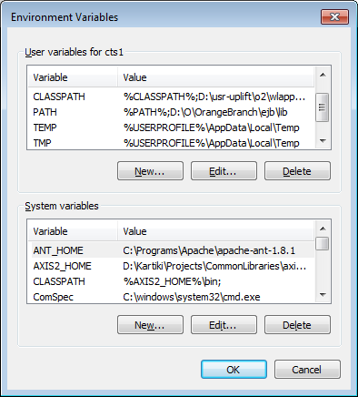

Then create new Catalina Base path and fill up details as below

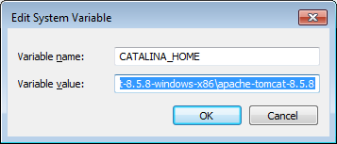

After clicking Ok, you will see Catelina Base Path is added.

  - Set GRADLE_HOME in Environment variable:

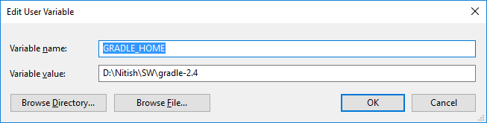

  - Set JAVA home path to latest java version (i.e. C:\Program Files\Java\jdk1.8.0_111

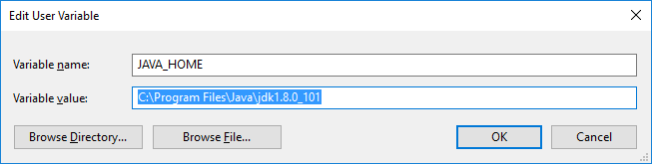

  - Append GRADLE_HOME\bin and JAVA_HOME\bin to “Path” in System variables as below:

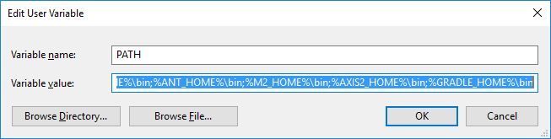

Build Application

4.1 PUK Application

- Open Command Prompt
- Go to base PUK folder (PUK_BASE) where you cloned the code
- copy vagrant folder from PUK_BASE to CatAlina_HOME\webapps
- Change following entries :
  - Open PUK_BASE\src\main\resources\config.xml
  - Change valu of resourceLoaderPath property of velocityConfig bean to CatAlina_HOME\webapps\vagrant\content
  - Open PUK_BASE\src\main\resources\logback.xml
  - Change BASE_PATH to location where you want logs to be generated like D:\logs
- To build the application, run gradle clean build or ./gradlew clean build
  - It will create war file (puk.war) in build directory of project. (PUK_BASE\build\libs)
- Run gradle clean eclipse OR ./gradle clean eclipse to build eclipse project

4.2 Fake services
- Open Command Prompt
- Got to PUK_FAKE_BASE location
- To build the application, run `gradle clean build` or `./gradlew clean build`
- This will create war file for PUK fakes in build directory of project. (PUK_FAKE_BASE \build\libs)
- To import dependency files for eclipse, run `gradle clean eclipse` OR `./gradle clean eclipse`

Deploy Application

5.1 Without fake services i.e. connect to AG
- Copy War from PUK_BASE\build\libs\puk.war into tomcat’s webapps
- Create folder structure as CatAlina_HOME\appdata\getpuk
- Copy getpuk.properties from PUK_BASE\src\main\resources\ to CatAlina_HOME\appdata\getpuk
- copy PUK_BASE\Certificates.zip file to CatAlina_HOME\appdata\getpuk folder and unzip the same there. This includes the certificates in .jks format
- Update following properties in PUK_BASE\src\main\resources\ getpuk.properties :
  - soaKeyStoreCertificateLocation to absolute local path of the .jks certificate file from PUK_BASE\Certificates
  - soaTrustedStoreCertificateLocation to absolute local path of the .jks certificate file from PUK_BASE\Certificates
  - application.asset.paths to accordingly for folder of CatAlina_HOME\webapps\ vagrant
- Modify changes in host file at C:\Windows\System32\drivers\etc and add following entry at the end of the file and save
127.0.0.1 localhost.ref.o2.co.uk

5.2 With fake services i.e. connect to Fakes instead to AG

- Copy War from PUK_FAKE_BASE\build\libs\ pukfakeServices.war into tomcat’s webapps
- Create folder structure as CatAlina_HOME\appdata\getpuk
- Copy getpuk.properties from PUK_BASE\src\main\resources\ to CatAlina_HOME\appdata\getpuk
- copy PUK_BASE\Certificates.zip file to CatAlina_HOME\appdata\getpuk folder and unzip the same there. This includes the certificates in .jks format
- Update following properties in PUK_BASE\src\main\resources\ getpuk.properties :
  - application.asset.paths to accordingly for folder of CatAlina_HOME\webapps\ vagrant
  - service_end_point to http://localhost:8080/ pukfakeServices/Service/Subscriber_2_0
  - reCaptchaServiceUrl to http://localhost:8080/ pukfakeServices/fake/recaptcha/
- Modify changes in host file at C:\Windows\System32\drivers\etc and add following entry at the end of the file and save
127.0.0.1 localhost.ref.o2.co.uk

Running the Application
- Connect to odl so you can access AG services (for running without fake service)
- Start tomcat and access the application at
http://localhost.ref.o2.co.uk:8080/puk
- Access healthcheck page at http://localhost.ref.o2.co.uk:8080/puk/healthcheck

